**Assignment Sqoop**

Task 1

Use Sqoop tool to export data present in SQOOPOUT folder made while demo of Import table

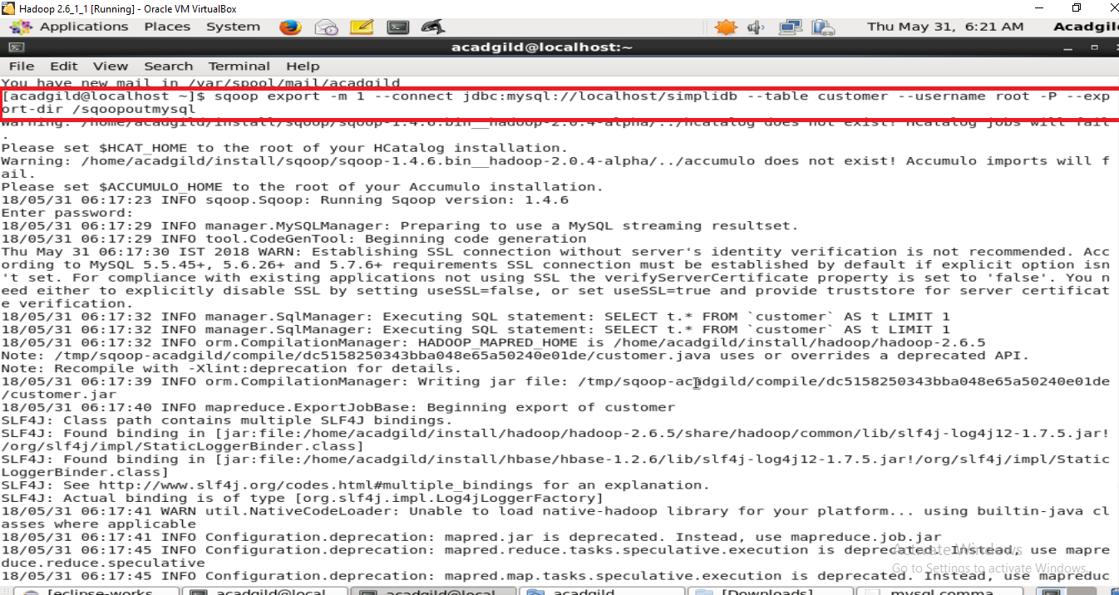

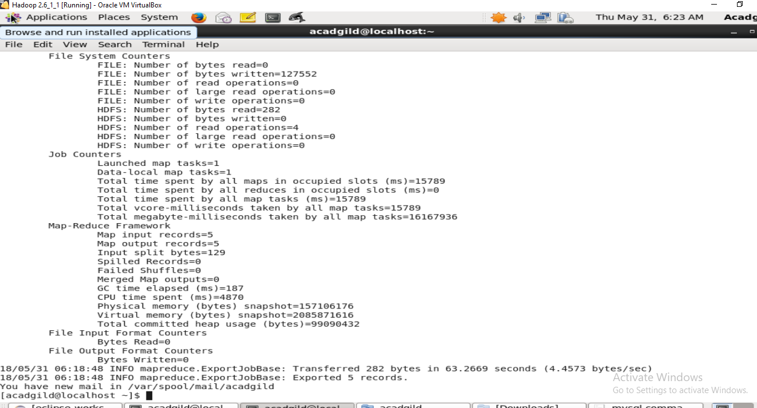

**Output in DB**

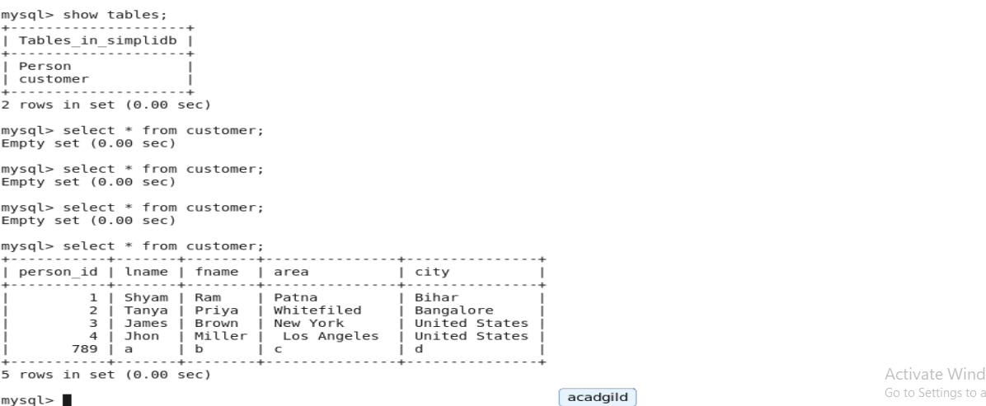

**Task2**

**Use Sqoop tool to export data present in SQOOPOUT folder made while demo of Import table**

**with parameter person_id =3.**

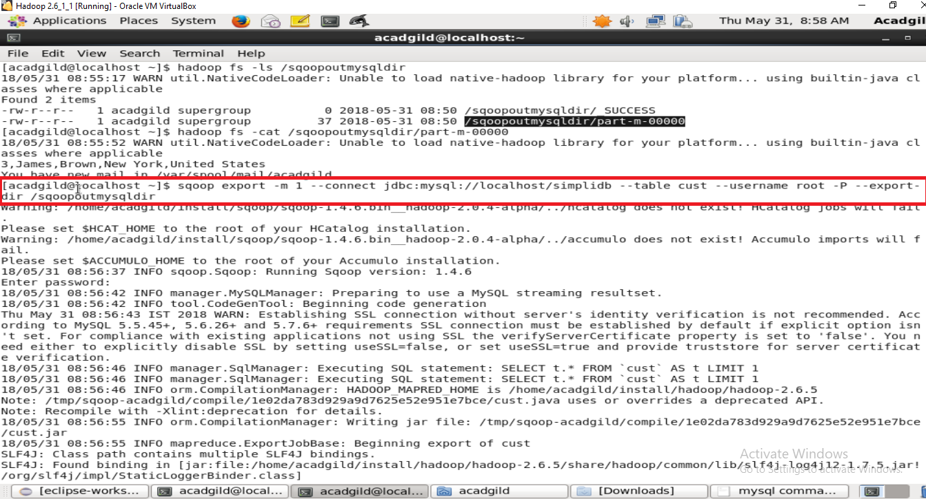

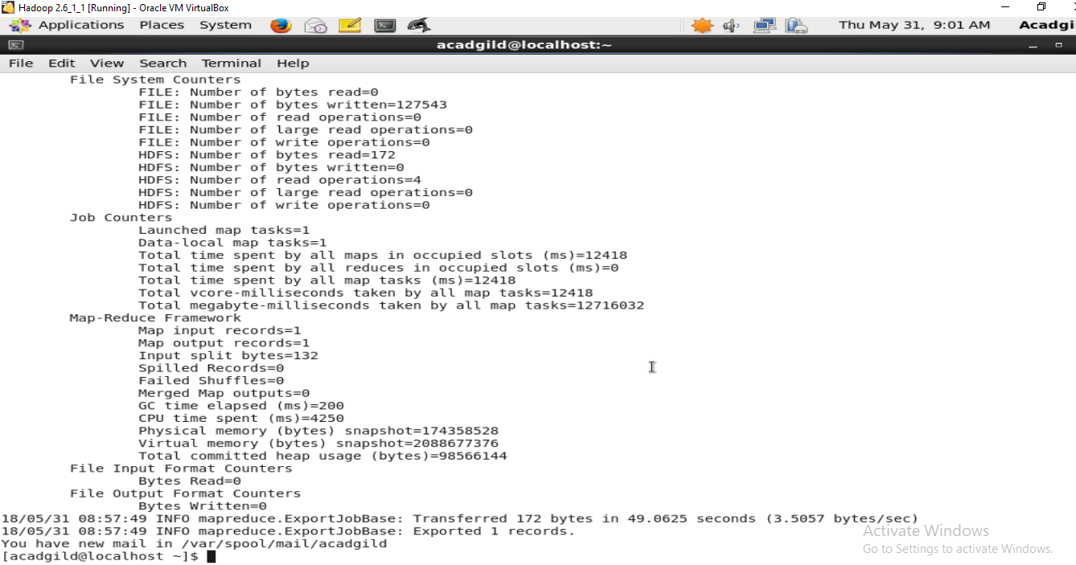

Out Put of DB

